**WHAT IS NEURODESK?**

Neurodesk is an open-source, containerized platform designed for reproducible neuroimaging data analysis, making it easy for researchers to access and use specialized tools across desktops, high-performance computers, the cloud, or web browsers without installation hassles or compatibility issues.

It enables flexible, scalable workflows for tasks like data processing and visualization, ensuring consistent results regardless of the user's computing environment by bundling software in portable containers.

https://play.neurodesk.org/.

Let's help you set it up.

1. **Tap the link provided in the readme.md**

The link then takes you to a page that looks like this.

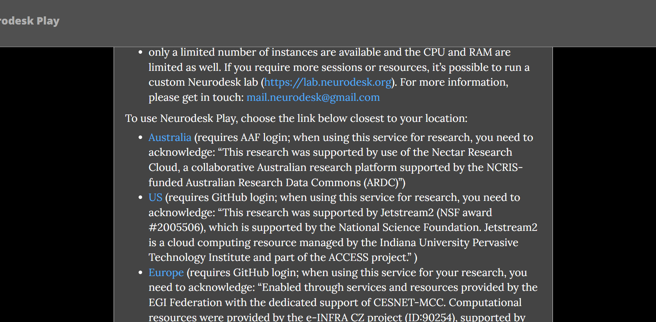

Tap the country that you are closest to. When that is done, you will be redirected to Jupiter notebook.

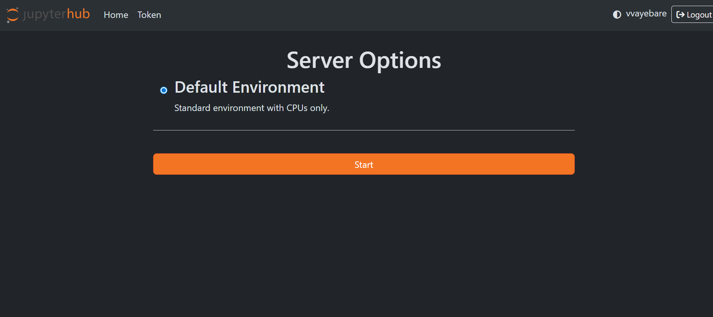

**CLICK START**.

You will then see this page. Don’t worry it takes long only the first time or if you have weak internet.

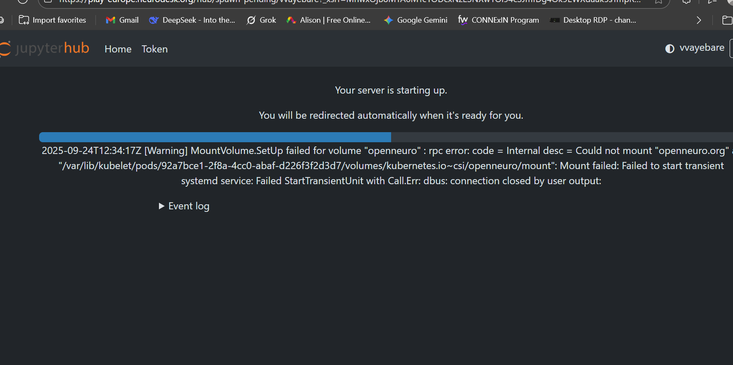

You will then be redirected to a page where you will have to **choose neurodesk**. And then **choose neurodesk RND.**

You will then be redirected to a screen that looks like this.

